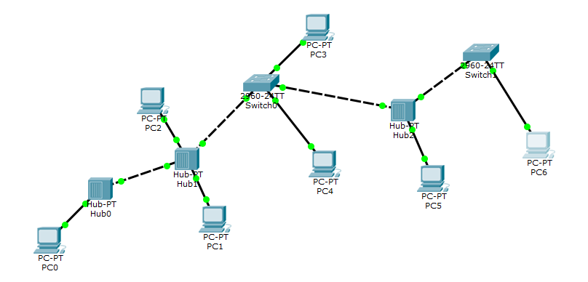**Task No. 1:** Implement the following network on packet tracer.

Ping,

1. PC0 from PC5,
2. PC6 from PC2,
3. PC3 from PC1,

Also, display the above results in the simulation mode of packet tracer. Attach snapshots of the pinging results and the network created.

**Solution:**

Complete the following table:

|  |  |
| --- | --- |
| **End Device** | **IP Used** |
| PC0 | 10.10.10.1 |
| PC1 | 10.10.10.2 |
| PC2 | 10.10.10.3 |
| PC3 | 10.10.10.4 |
| PC4 | 10.10.10.5 |
| PC5 | 10.10.10.6 |
| PC6 | 10.10.10.7 |

**Output:**

* + - 1. **PC0 from PC5,**

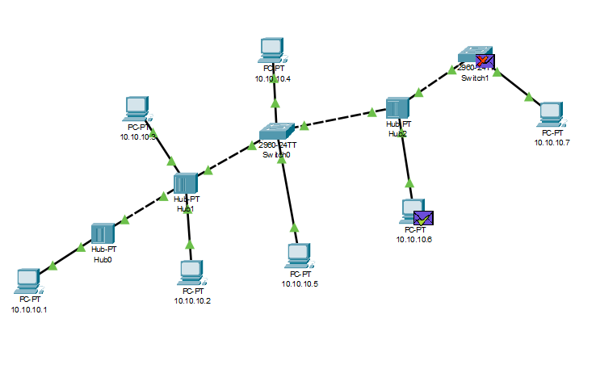

* + - 1. 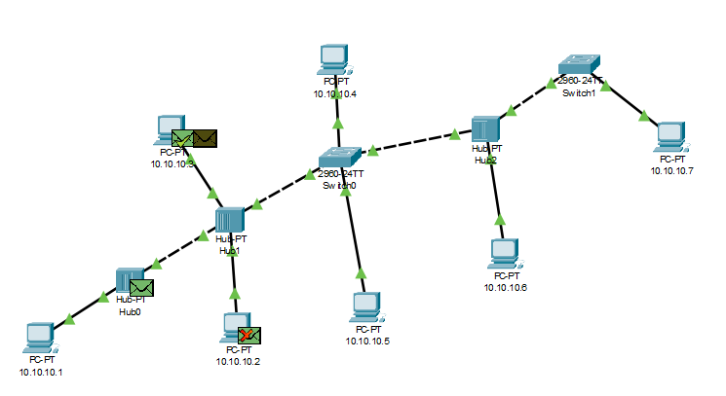**PC6 from PC2,**

* + - 1. A computer network diagram with green arrows and black lines

         Description automatically generated with medium confidence**PC3 from PC1,**

